World Happiness Report

## UCI Data Analytics Bootcamp - Project 2

**Project Team**

Jeffrey Wang

Nurbol Batkhan

Rose Militante

**Dataset source:**

* Kaggle
* <https://www.kaggle.com/unsdsn/world-happiness>
* Years 2018 – 2019

**Github Repo:**

* https://github.com/hjeffreywang/Project-3-Web-Development.git

**Project Inspiration:**

Utilizing the World Happiness Report found on Kaggle.com from happiness scores and rankings from the Gallup World Poll, our team sought to create a python, full-stack application to address and visualize the following questions:

* What countries or regions rank the highest in overall happiness?
* What are the six factors contributing to happiness in these highly ranked happy countries?
* Does geographical location influence the highest and lowest ranked countries?

**Summary:**

Our team sought to create an interactive dashboard page that was powered by two data sets from 2018 and 2019 World Happiness data. Each data set contained over 156 records representing the countries polled. A ‘Select Year’ toggle is present on the ‘Home’ page allowing a user to select between 2018 and 2019 data. This selection event controlled the 2 charts present: ‘Top 20 Happiest Countries’ and ‘Average Factor Contributions’. The selection event also filtered the viewable dataset present on the ‘Home’ page. In addition, a user could make a selection at the top navigation pane along with 4 selectable images leading the user to view linked pages containing further visualizations. All pages were stylized using a combination of CSS and bootstrap.

The original data was originally in CSV form and had to be converted to SQLite form via SQLiteStudio. Once that is done, routes for the data are created in python and made callable to the javascript calls. The  bar charts for the happiest countries and the highest average factor scores were made by using D3 to search for the data at the routes created in python. Once the data is assigned, plotly is used to create the graphs.

For the datatable, a javascript package called DataTables is used. It also requires JQuery and JQueryUI packages. Once D3 is assigned the JSON, the table is created and the column titles are made.

Pages 2 and 3 worked on by Rose, focused on visualizing the six factors contributing to a country’s happiness ranking. The main chart at the top utilizes d3 and plotly to create scatter plot charts for each of the 6 factors. These factors are individually selectable below the x-axis allowing for each factor to be visualized through a newly rendered chart without needing for a new page to load. The y-axis represents the countries and their determined happiness ranking provided within the datasets. Hovering over the plots presents a tooltip with additional information showing the country name, factor and factor score. In lieu of creating a means to toggle between the 2 years reviewed, Rose created the same chart between 2 pages to visualize the factors data by year.

Rose wanted to include a quick visualization of the top 5 ranked ‘happy’ countries and show the countries’ scores for the 6 factors. Due to time constraints, this could not be done quickly using d3/plotly. Instead, Rose utilized Tableau to visualize the bar charts and included these embedded images at the bottom of pages 2 and 3.

Nurbol worked on Pages 3-4, visualizing the world map that the first and least ten countries based on their world happiness scores. We mainly used leaflet.js and API from mapbox.com to visualize the map. The first ten countries are shown on yellow circles and the least ten countries are shown on red circles. The size of the circles are based on the happiness score. Higher the happiness score, bigger the circles are. Popups are made on each circle to give certain key information such as happiness score, name of the country and the rank.

Nurbol wanted to visualize all the countries in contrast based on the happiness scores. For instance, color of the counties, lower the happiness score, more red color they are.

**Main/Home page**

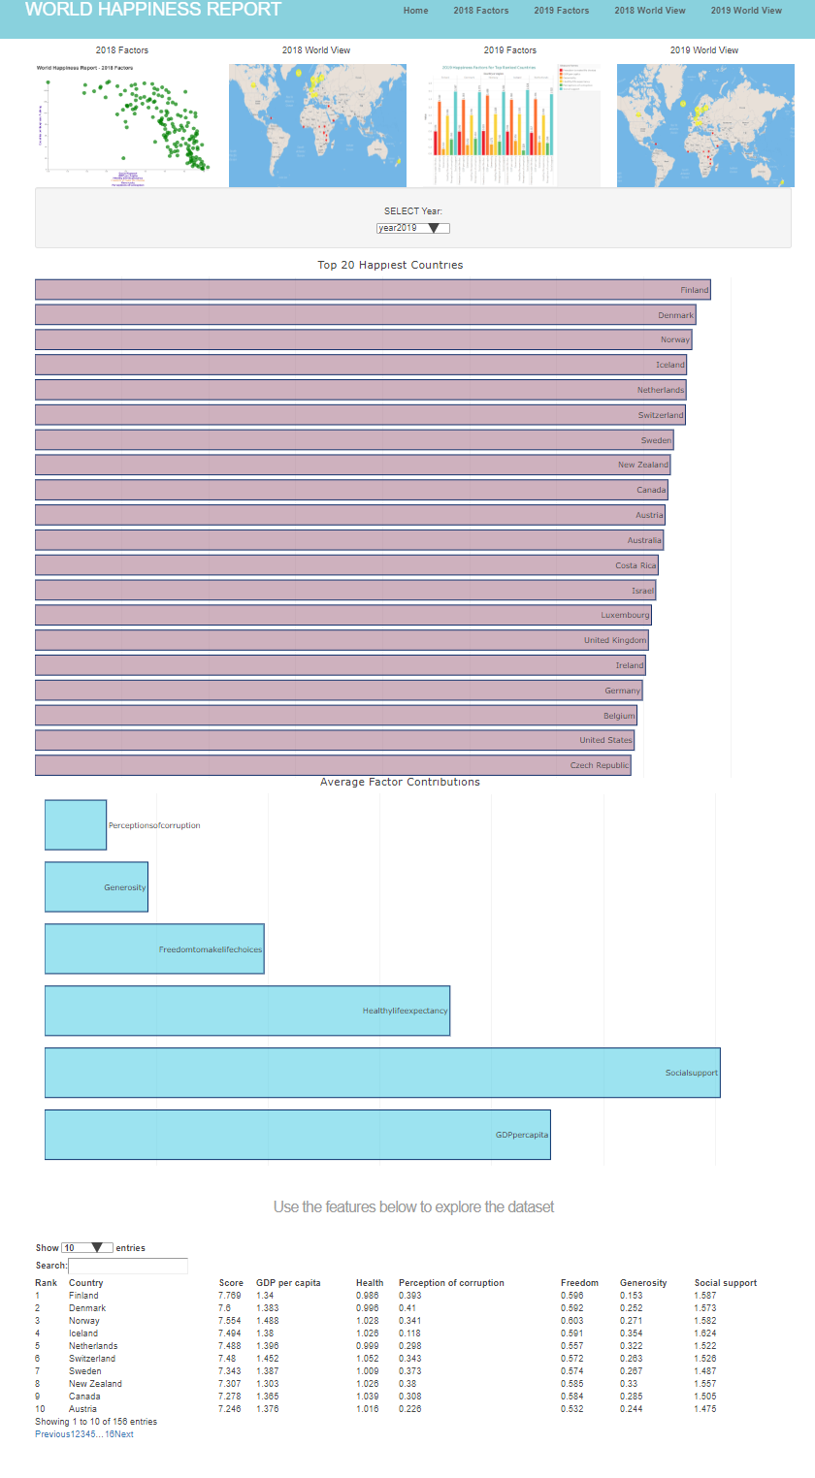

**Pages 2-3: 2018 and 2019 Factors**

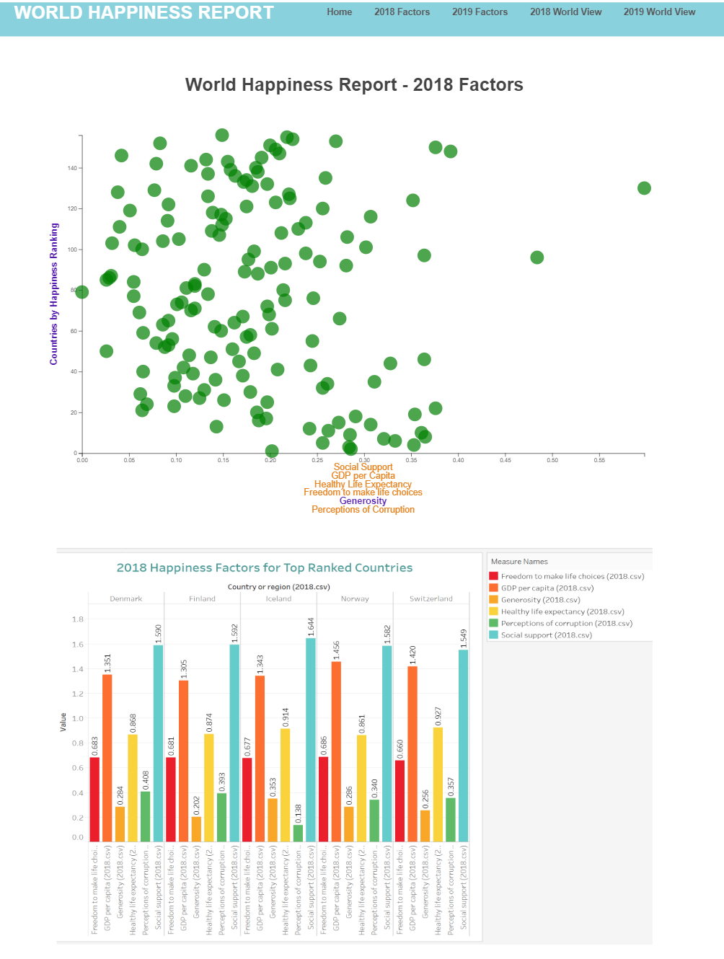

**Pages 3-4: 2018 and 2019 World Maps**

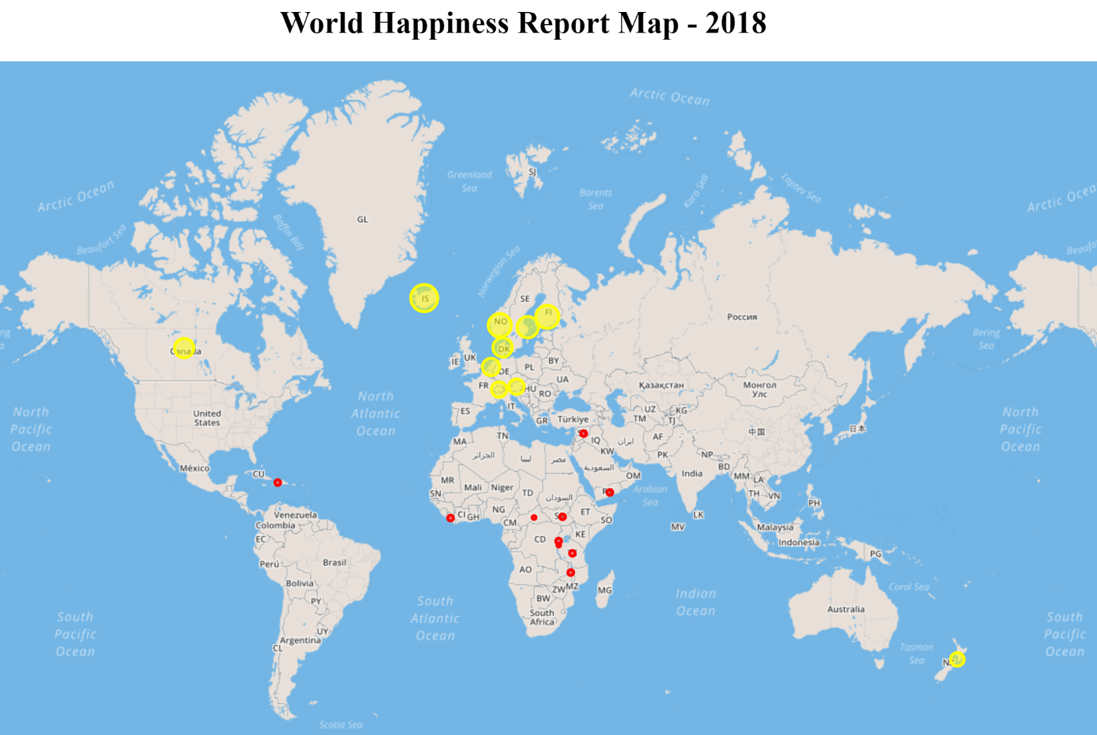

**SQLite**

Convert CSVs to SQL using SQLiteStudio

**Python**

Import packages

Preview the data

Create routes that link JSON data to an address for javascript calls

**JS script**

Create bar graphs by using D3 to link routed json data and plotly for the graphs.

Create sortable datatable using D3 and link the data to the DataTables javascript package.

Start the script with init function, which also creates a select bar for 2018 and 2019 data

Whenever another option is chosen, the option changed function will update the data and remake the data table